Farmer Brown
TASMANIAN DAIRY INDUSTRY AUTHORITY
FARM DAIRY PREMISES
EFFLUENT MANAGEMENT PLAN

- PO Box 303
Devonport Tas. 7310
: 6421 7689
: 6421 7667
: 0419 315 805
E: Don.Sandman@dpipwe.tas.gov.au

Introduction
All dairy farm premises generate dairy effluent - it is important that this effluent is soundly managed and not ignored. Dairy Farmers, like all members of society, have a duty not to pollute the environment.
A Farm Dairy Premises Effluent Management Code of Practice (the Code) has been designed to ensure that dairy farm effluent is managed in a responsible manner which is unlikely to have a negative impact on the environment. It is a requirement under the Code that all dairy farms have a Farm Dairy Premises Effluent Management Plan in a form approved by the Tasmanian Dairy Industry Authority. This form of a Dairy Premises Effluent Management Plan is approved by the TDIA.
Compliance with the Code should reduce the potential for environmental harm or environmental nuisance as defined by the Environmental Management and Pollution Control Act 1994 (EMPCA). This Code is made pursuant to the Dairy Industry Act 1994, and operators of dairy premises must comply with its requirements.
The Code lists three outcomes that dairy effluent management systems must comply with. These outcomes are;
- Dairy premises effluent must not leave the farm boundaries or enter surface water or groundwater, unless treated and discharged in a manner approved by the relevant authorities.
- There must be an appropriately designed and operated system for the responsible management of dairy premises effluent.
- Spray irrigation or distribution of dairy premises effluent is carried out in an environmentally sound manner.
The design and effective implementation of a Farm Dairy Premises Effluent Management Plan is a vital component of the effluent management system.
This plan is a generic Farm Dairy Premises Effluent Management Plan designed for adoption by Tasmanian dairy farmers. By completing the plan farmers will state the design and capacity of their current effluent treatment system and state how this system manages the treatment and application and reuse of dairy premises effluent.

While the TDIA may accept and approve a completed plan, situations may arise where following the plan may not ensure compliance with the Code. It is the duty of the landowner to ensure that the outcomes of the Code are met in these situations. In that event, the plan (or management practices) will need to be modified and reapproved by the TDIA.

- Property Information
Owner
Location
License |  | ph/email
Current herd size
Dairy type
Milking season
Current Effluent Mgt Plan

Farm specific values
Waterways
Drainage channels
Bores
Slope/topography
Neighbouring residence
Sensitive areas

Catchment information
Soil type
Annual rainfall
Water table
Water source
Evapotranspiration rate
Groundwater use

Current effluent system
Effluent Drainage from Dairy
Conveyance from shed
Yard collection method
Sand and gravel trap
Sand and gravel trap cleaning frequency
Solids Separation
Solids separation method
Effluent Storage
Storage system type
Storage pond capacity (ML)
Sump capacity
Storage period
Effluent produced in dairy per year
Total volume of water use per year
Pond emptying
Pond emptying method
Timing
Application area (ha)
Paddock rotation
Withholding period for grazing
Sludge removal
Sludge application method
Cleaning frequency
Sludge application frequency
Ponds crusted
Application approach
Irrigation method
Irrigation application (ha)
Paddock rotation
Application rate
Withholding period for grazing

Management of effluent system

 | Yes | No | N/A | Comments
Does all dairy effluent produced from point sources enter the effluent management system?
Does your effluent system completely retain all the effluent within farm boundaries all year round?
Is your system designed to prevent effluent reaching surface water?
Can effluent ponds be completely isolated from the irrigation re-use system?
Is the effluent pond impermeable?
Is the floor of the dairy and holding yards impermeable?
Is there appropriate bunding in the dairy?
Is the emergency disposal of milk prevented from entering the effluent system or nearby waterways and drains?
Are manure stockpiles appropriately enclosed to prevent runoff into surface water?
Is effluent storage emptied annually prior to wetter months?
Is the effluent pond desludged regularly/as appropriate?
Has the effluent system been upgraded following any significant changes to the milking shed or herd?
Are there future plans for the farm that would impact on effluent management?
Are there adequate buffers in place around sensitive areas?
How often is effluent equipment serviced?
Who is responsible for maintaining the effluent system and this plan?

Emergency management and contingency

 | Yes | No | N/A | Comments
Do you carry spare parts/back up equipment in case of pump breakdown?
What happens with effluent if the ground is too wet for irrigation?
Is adequate storage available during wet periods?
How is an effluent spill contained/managed to ensure it does not leave your property?
Who would you contact in the event of an effluent spill? |  |  |  | Local council Environmental Health Officer

Please note: You are required by law under the Environment Management and Pollution Control Act 1994 to report any spill that leaves your property to your local council as soon as practicable and at least within 24 hours.
As a landowner you have a legal responsibility to take all practical steps to prevent the discharge of pollutants into waterways, lakes, groundwater, wetlands or water courses.

Contact Numbers
Farm Manager |  | Plumber
Electrician |  | Earth moving contractor
Council EHO |  | Irrigation/pump supplier

Recommendations
Please be aware that a minimum requirement of the Farm Dairy Premises Effluent Management Code of Practice is that appropriate contingencies must be in place to contain all effluent regardless of weather conditions or mechanical breakdowns. Contingencies include building a temporary levee wall to contain the spill and digging trenches to divert effluent out onto paddocks as well as redirecting effluent inflows from the dairy shed to other storages or temporary bunded areas until repairs are completed.

If milk is required to be disposed of, consider diluting it with 6-7 parts water to one part milk and irrigating it as far from waterways as possible. Under no circumstances should milk enter waterways as it is extremely toxic and kills all aquatic life. If milk can be fed to calves, that would be preferable. It is not advised that milk be disposed of into effluent ponds as this can produce odour and reduces the efficiency of the pond for several months.

Appropriate maintenance of the system may include desludging the settling pond periodically. Regularly cleaning out the pond will allow it to work more effectively and efficiently and prevent issues with the greenwater pond, particularly the buildup of solids and blocking the pump.

It is recommended that after effluent is irrigated over paddocks, there be a period of 14 days before animals graze those pastures again. If slurry is being irrigated or spread, allow 21 days before cows graze the same paddocks. There is potential for stock to become ill if they graze pastures too high in nutrients.

The TDIA has 23 additional recommendations to deal with a variety of applications!

Date established: 2015 Date approved: _______________________

Name: _______________________________ __________________________________
(Landowner) (TDIA Officer)

Signed: _______________________________ _________________________________

Attachment 1: OH&S
It is the responsibility of the landowner to identify any foreseeable hazards that may arise and that have the potential to harm the health and safety of anyone on the farm. Their principal duty is to take all reasonable and practicable steps to protect the health and safety of their employees and others that may be present, such as children and other visitors.
Where the property is leased or share-farmed, the person who has control of the workplace must take all reasonable and practicable steps to ensure the workplace is safe. However, the landowner/employer also retains a duty of care to the lessee/sharefarmer to ensure the premise is safe.
Issues you should consider in regard to OH&S and effluent management systems include:
- The potential release of hazardous gases as a result of storage, pumping, mixing, spreading and cleaning out (hydrogen sulphide, carbon dioxide, ammonia and methane);

- Avoidance of using tractors near the edge of effluent ponds unless chocks or low barriers are in place to prevent the tractor moving backwards; and

- Fencing, or at least ensuring children and others are aware of sumps, solids traps and ponds so there is no danger of them falling in.
Additional information is available at www.dairysafety.org.au

Attachment 2: Effluent Application Plan
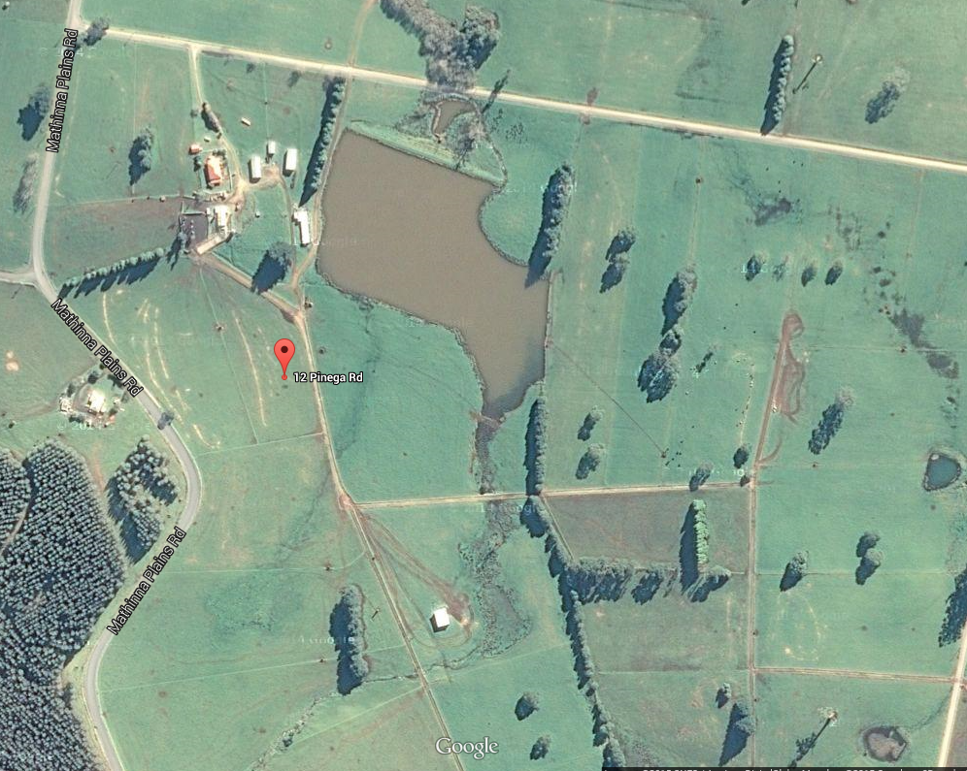
Dairy Effluent management system Effluent application area Roads/laneways and houses/sheds

Attachment 3: Assessment of current effluent management system
Effluent Management | Unacceptable  Practice | Acceptable  Industry Practice | Above  Acceptable Industry Practice
Effluent Collection | No system for collection or distribution. Effluent leaves the property via surface or groundwater or land runoff | Effluent is retained on the property and does not pollute surface or ground water or road sides. | Effluent is retained on the property and reused for production gains.
Effluent Pond Systems | Pond(s) have been incorrectly sized and cannot contain effluent over the wetter months. | Pond(s) have been correctly sized by an expert, taking into account specific farm and region information, such as herd size and rainfall. | Pond(s) have been correctly sized by an expert, taking into account specific farm and region information, including potential expansion options.
 |  |  | The system has been designed to cater for multiple effluent sources, such as calf sheds, feed pads, additional yarding etc.
 | Pond(s) are poorly located and do not take into account appropriate buffer distances. | Pond(s) have been integrated into the farm plan and maintain appropriate buffer distances. | Pond(s) have been integrated into the farm plan and maintain appropriate buffer distances and future modifications.
 | Pond(s) are constructed with permeable material, resulting in seepage. | Pond(s) have been built using impermeable material or appropriately lined with clay or synthetic liners to prevent seepage. | Pond(s) have been built using impermeable material or appropriately lined with clay or synthetic liners to prevent seepage. Liners are regularly checked to rectify damage.
 | Pond(s) are not emptied or desludged. | Pond(s) are emptied regularly during the season and nutrients used on-farm to improve production. | Pond(s) are emptied regularly during the season and nutrients used on-farm to improve production.
 |  |  | Pond(s) are agitated to remove nutrients
 |  | Desludging is carried out when required. | Desludging is carried out routinely as part of a pond maintenance program.

Effluent Management | Unacceptable  Practice | Acceptable  Industry Practice | Above  Acceptable Industry Practice
Sump System for direct application | Sump/trap is undersized and regularly overflows. | Sump/trap has been correctly sized to cater for water inflows used for yard cleaning, such as hoses, floodwash and hydrants. | Sump/trap has been correctly sized to cater for water inflows used for yard cleaning, such as hoses, floodwash and hydrants.
 |  | Sump/trap has sufficient holding capacity to retain effluent to allow breakdowns to be rectified promptly. | Sump/trap has sufficient holding capacity to retain effluent to allow breakdowns to be rectified. A spare pump and parts are on-hand.
 | Sump/trap does not protect the pump or conveyance pipe from stones and debris. | Sump/trap to stop stones and debris entering the pump and conveyance system. | Sump/trap designed to stop stones and debris entering the pump and conveyance system.
 |  |  | Weeping walls or stone traps cleaned regularly. Materials such as gloves, syringes, horns etc, removed regularly.
Yard wash down | No consideration for water reduction or excessive washdown times | Overall water use has been evaluated and water use reduction practices implemented. | Water recycling options undertaken to reuse platecooler water and recycled effluent water for yard cleaning.
 | Dairy shed and yard poorly designed, not promoting good cow flow. Herd stressed and depositing more effluent in the yard. | Dairy shed and yard designed to accommodate good cow flow. Yards have good slopes to make cleaning more efficient. | Water quality monitored regularly to avoid high salinity levels affecting ponds or pasture applications.
 |  |  | Dairy shed and yard designed to accommodate future expansion and allow good cow flow. Washdown systems designed to minimize water use

Effluent Management | Unacceptable  Practice | Acceptable  Industry Practice | Above  Acceptable Industry Practice
Application  System | No effluent application system to pastures. Effluent directed to a sacrifice paddock. | Effluent application system in place, enabling effluent to be distributed over suitable farm area to utilize the nutrient and water value, resulting in a production gain. | Effluent application system rotated around the farm strategically to match application rates with soil, pasture and crop requirements.
 | Effluent irrigation sprinklers are rarely moved or rotated, limiting the area over which effluent is applied. . | Appropriate buffer distances separate effluent irrigation areas from sensitive areas such as neighbouring residences and waterways. | Appropriate buffer distances separate effluent irrigation areas from sensitive areas such as neighbouring residences and waterways.
 |  |  | Timing of effluent irrigation is managed strategically to minimize effect on sensitive areas. Effluent is tested for nutrient value before application.
Management | The system was not upgraded following herd/infrastructure changes. | The system has been reviewed and has the ability to cope with the current herd/infrastructure. | The system has been upgraded to cope with herd/infrastructure change. This includes additions such as feedpads.
 | No maintenance schedules in place to maintain pumps, ponds or equipment. | The effluent system equipment is serviced on a regular basis, as per the manufacturer’s specifications or by qualified professionals. | The farm implements a routine monitoring and maintenance program to service equipment as per the manufacturer’s specifications or by qualified professionals. Back up equipment is available for emergencies.
 | Manure stockpiles from pond desludging or trap cleaning located in close proximity to waterways. | Manure stockpiles are stored in an appropriate location away from sensitive areas and applied to pasture once dry. | Manure stockpiles are stored in an appropriate location with bunding and strategically applied to pastures following a nutrient analysis.

Effluent Management | Unacceptable  Practice | Acceptable  Industry Practice | Above  Acceptable Industry Practice
 | The farm has no awareness of OH&S practices. | The farm is aware of and implements appropriate OH&S requirements. | Appropriate OH&S requirements are implemented on-farm and staff are trained accordingly,
Feed Pads | No effluent system for the system is in place or there is no control of nutrient run-off. | An appropriately designed effluent system is in place taking into account relevant variables. | An appropriately designed effluent system is in place taking into account relevant variables.
 | Feedpad is sited on/close to sensitive areas (waterways, neighbours, flood points) | Feedpad is integrated into the farm layout to maximize production and minimize off-site impacts. | Feedpad is integrated into the farm layout to maximize production and minimize off-site impacts. Odour and noise issues have been considered.
 | Feedpad constructed on permeable soil (sandy), in areas with a high water table & no means of protecting ground water. | Feedpad constructed on low permeability soil (clay) or appropriate foundations to minimize nutrient infiltration. | Feedpad concreted to eliminate nutrient infiltration to the soil.
 | Feedpad has inadequate drainage, causing boggy and slippery surfaces. | Feedpad incorporates has good drainage and does not become boggy in wet weather. | Feedpad has reinforced concrete aprons to assist in regular maintenance and to enhance drainage.
 | No routine for dry scraping manure and waste feed. Stockpiled manure located in close proximity to sensitive areas. | Manure and waste feed is regularly scraped and stored in a contained area to allow drying and reuse. | Manure and waste feed is regularly scraped and stored in contained area for reuse.
Source: Dairying for Tomorrow: DairySAT, Dairy Australia, 2009

Attachment 4: Checklist/Action plan for effluent system management

What | When | Who
Milking Shed
Minimise water usage where possible
Check drains and grates for blockages and clean if necessary
Check drains, gutters and downpipes and repair if required
Effluent System
Clean out stone trap
Check irrigator for blockages
Check effluent spray is not drifting over boundary or onto calf paddock.
Move irrigator as required with effluent application plan
Check that effluent is not ponding in application area
Check for leaks and blockages in pipes and joins
Check for adequate freeboard/capacity in final storage pond.
Inspect effluent pump and irrigator
Ensure stock not grazing treated pasture within 14 days of effluent application or 21 days plus for slurry applications
Ensure effluent ponds are lowered as far as possible during dry months
Desludge ponds. Spread sludge on paddocks following soil fertility testing
Service equipment, eg pumps, irrigator
Emergency Management
Immediately notify manager of any spills
Organise immediate containment of spill
Notify Council if spill not contained on the property
Immediately notify Manager of any malfunction in effluent management system
Organise immediate repairs to effluent management system

